**Extracting Rib Structure from Two-dimensional Chest X-ray using High Dynamic Range Imaging Method in OpenCV**

Jimin Han

*Daewon Foreign Language High School, Seoul, Republic of Korea*

**Abstract**

**Background:** X-ray radiography is a common basic diagnostic method used in medicine. Among them, chest X-ray is a basic test for diagnosing the human structure in the chest, and requires a lot of experience to be read because it projects various structures such as the lungs, heart, spine, and ribs into two-dimensional images. In particular, rib bones overlap with other chest structures, making it difficult to distinguish them.

**Purpose:** This study is designed to produce a modified chest X-ray image that distinguishes the rib well using various post-processing method in OpenCV library.

**Methods:** We made post-processing chest X-ray images to make rib bone prominent using histogram equalization, calBackprofect, Laplacian filter and Gaussian blur filter among the open source code in OpenCV. And the quality of these images was verified by using voting and Harris corner detection method and a high dynamic range image in which rib bones are prominent was implemented through the generative adverse network method by applying above converted images.

**Results**: The lung shadow was well reduced in the histogram equalization and Laplacian filer postprocessing images, and as a results of processing the HDR images algorithm using these images, the chest X-ray image which distinguish the ribs well was finally implemented.

**Conclusion**: The HDR imaging technique using various post-processing images in this study can produce a rib distinguishable chest X-ray.

**1. Introduction**

Medical image processing is the imaging of all medically useful biometric information including tissues and organs inside the human body. Actually, there is a difference between imaging and image processing. Imaging refers to the physical and mathematical methods of producing an image. Image processing is more concerned with working with already existing images to remove noise, segment regions of interest, etc. It is a generic term for all technologies that extract and process clinical information that is useful for diagnosis or treatment from all biometric information. The recent advances in information technology and computing power have motivated increased interest in medical image processing.

Among numerous types of computational processing, image enhancement plays an especially important role since it is one of the preliminary steps that are taken before starting image analysis. Image enhancement is widely used in X-ray, computed tomography (CT), and magnetic resonance imaging (MRI), where various image processing technologies have recently been applied to improve the quality and information content of images.

The sharpness and quality of the image determines the accuracy of diagnosis. The general opinion of the medical community is that two-dimensional image, especially the chest x-ray image, is inaccurate in the determination of bone structures due to interference with surrounding complex lung tissue. It is known that detection of fracture or evaluating the abnormal bone structure in chest x-ray is hard and the diagnostic rate of rib fracture using chest x-ray is about 50%.1 Therefore, additional scan such as bone scan or computed tomography (CT) scan may be needed for a more reliable diagnosis. However, these tests put the patient at risk of exposure to more radiation. However, if a specially processed chest x-ray can easily distinguish the bone, we can easily evaluate the bone structures without performing an additional diagnostic method. This may reduce the risk of patients being exposed to more radiation to diagnose the fracture.

Recently, Intel provided public access to Open Source Computer Vision (OpenCV) programing library to allow free image processing, so that we can make image conversion easier.2 Therefore, if post-processing can be more easily applied to detect the bone structures in a chest x-ray, it would be possible save the time and reduce costs, which are associated with using additional diagnostic tools.

The purpose of this study is to investigate whether the post processing methods such as histogram equalization, calBackproject, Laplacian filter and Gaussian blur filter are effective for extracting bone structures from chest x-ray images and to assess whether high dynamic range (HDR) image using these verified images are effective in implementing bone extraction chest x-ray.

**2. Materials and Methods**

This study was performed by using authors’ own chest x-ray. This image is formatted as a JPG file of 153Kb in size. No other images were used in this study. The OpenCV is a programming library for real-time computer vision. It was originally developed by Intel and focuses on real- time processing. By using OpenCV, we performed image processing and analyzed the final image.

In order to implement HDR algorithm, various post-processing images were used to make ribs look better. In this study, several image post processing algorithms in openCV were used to transform the image, and among them, the images which the ribs were clearly visible, and the noise were reduced were selected and used for the final HDR algorithm.

**2.1. Intensifying the black color by histogram equalization of the X-ray image**

Histogram equalization is used to improve the contrast in images by spreading out the most frequent intensity values. It accomplishes this by effectively spreading out the most frequent intensity values, i.e. stretching out the intensity range of the image. This method usually increases the global contrast of images when its usable data is represented by close contrast values.3 This allows for areas of lower local contrast to gain a higher contrast. As a way of assessing the image transformed by this method, five independent evaluators were asked to vote on where the rib images were more clearly visible, and an assessment of the image clarity was conducted. The independent evaluators did not know what post processing was performed for the both images.

**2.2. Extracting rib images by using calcBackproject**

Calcbackproject in OpenCV is an algorithm used to divide images or to find areas of interest in images.4 This is mainly used in the background projection method of histogram. Briefly, this algorithm can find a pixel that is probabilistically similar to the pixel we want and as a result we can extract specific images. The rib images can be selected and magnified for further examination of the equalized image by using this method. If we can segment out the rib image from the chest x-ray, we postulated that a more detailed evaluation of rib can be performed. We verified the extraction of ribs from the chest x-ray using calcbackproject algorithm.

**2.3. Laplacian filter and the Gaussian Blur comparison**

The Laplacian filter computes the second derivatives of an image. By doing so, it tests whether a change in adjacent pixel values is due to an edge or continuous progression.5 Since Laplacian detects an edge by summing the differences between a center pixel and its neighboring pixels in four or eight directions, it is very sensitive to noise and tends to detect false edges. Therefore, it is desirable to remove the noise from an image before applying the Laplacian filter.

The Gaussian filter is one of the most widely used blurring filters.6 When applying the Gaussian filter, the current pixel value is replaced by the weighted average of the neighboring pixel values. The closer to the current pixel, the larger is the weight. The premise behind the Gaussian filter is that the intensity of the pixel changes slowly so that the neighboring pixels have similar values. In contrast, noise is typically uncorrelated and is therefore suppressed in the weighted average.

**2.4. Harris corner detector to compare the two filtered images**

To compare the Laplacian filter process and Gaussian blur filter technique, we used Harris corner detector for both images. Harris corner detector is a corner detection operator that is commonly used in computer vision algorithms to extract “corners” and infer features of an image.7,8 If noise is reduced in the chest x-ray image and the distinction between each part of images in chest x-ray becomes apparent, this method may easily find corner points where rapid image changes occur. This is one of the ways to find a specific part of an image that has become clearer due to reduced noise. Using this method, we looked up which of the Laplacian filter or Gaussian blur filter find the corner points well.

**2.5. High-dynamic-range imaging (HDR)**

High-dynamic-range imaging (HDRI or HDR) is a technique used in imaging and photography to reproduce a greater dynamic range of luminosity than is possible with standard digital imaging.9 The principle of this method is to synthesize several photos with different exposures and synthesize dynamic range into algorithms to achieve a clearer image. By applying this method, the qualified post process chest x-ray image which was generated from this study are selected and HDR in OpenCV is used to create the final image product. In addition, the final HDR image is converted back to 8-bit SDR image to display in the typical display device.

**3. Results**

**3.1. Histogram Equalization**

After performing the histogram equalization, the contrast enhanced image was obtained (Figure 1). As a result of the evaluation of the images, five of five (100%) people agreed that the distinction between rib images in post-processing images was easier and confirmed that this method effectively distinguishes ribs.

The image accomplishes this by effectively spreading out the most frequent intensity values, i.e. stretching out the intensity range of the image. This method usually increases the global contrast of images when its usable data is represented by close contrast values. This allows for areas of lower local contrast to gain a higher contrast.

Fig. 2 displays the image histograms before and after equalization. It can be seen that the distribution of intensity values ​​in the image pixels has been made more uniform after the equalization. In summary, the histogram equalization method has improved the global contrast of the image and allowed for areas of lower local contrast to become more visible.

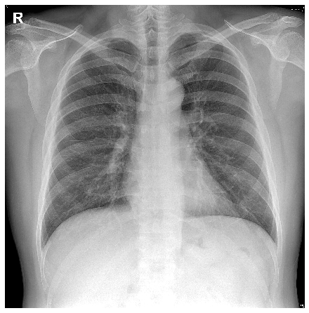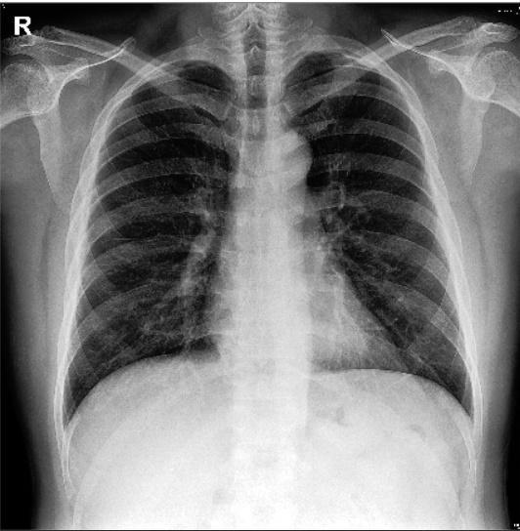

*Figure 1. The chest X-ray image before (left) and after (right) histogram equalization. In the right image, the contrast between white bones and the black background is increased. As a result, lung shadow was reduced, resulting in prominent rib shadow.*

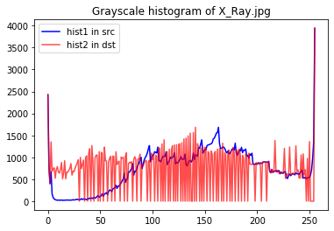

*Figure 2. The histogram of the image shown in Fig. 1 before (hit1) and after (hit2) equalization. The horizontal axis of the histogram is the intensity value, and the vertical axis represents the frequency at which it appears in the image. The original histogram had small values for pixel intensities between 0 and 100. The equalized histogram is much more evenly spread.*

**3.2. Extracting ROI by using calcBackproject**

As one can see in the Fig. 3, the red line (H1) shows the color distribution of the entire X-ray. The blue line (H2) compared the color distribution of region of interest (ROI) (ROI = (148, 156, 124, 201). By using this method, it is possible to identify abnormalities in a particular region or color distribution in a particular region.

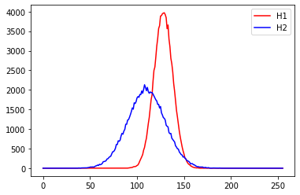

*Figure 3. Color distribution curve of a specific part of the x-ray image*

This is the color distribution curve when a specific part of the X-ray image is extracted with calcBackproject in Open CV. The X-axis represents the brightness intensity and the Y-axis represents the number of pixels. H1 is the color distribution curve of the entire area and H2 is the color distribution curve of the specific area, in other words the region of interest. To view images, go back to **Figure 4,** the H1 graph shows highly condensed color intensity values in the 100-150 ranges, where as in the H2 graph, the color distribution is more widely spread, ranging from 50-150. This means that there is higher contrast within the image that is extracted, and the color range is more tone-down.

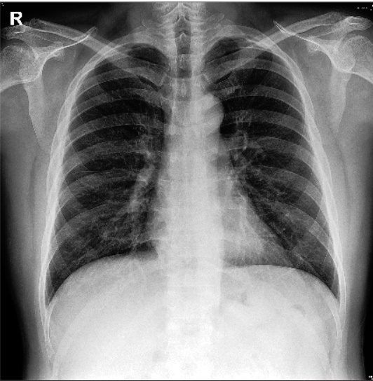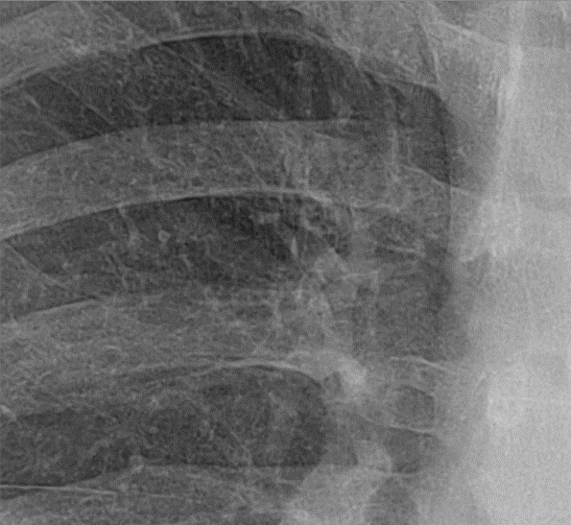

Figure 4. Equalized image (Left) and calcBack Project image (Right) after extracting the ROI (ROI =(774, 296, 600, 536)

**3.3. Laplacian filter and the Gaussian Blur Comparison**

The Laplacian filter and the Gaussian Blur are both applied in order to compare which filter is most effective in mitigating noise without degrading the original image quality. It can be clearly seen that the Gaussian blur somewhat degraded the sharpness of the image, while the Laplacian managed to maintain the resolution as well as reduce noise. (Figure 5) However, the difference between the two post process images is hard to distinguish. For this reason, the harries corner points detection method was used to accurately distinguish the quality of two images.

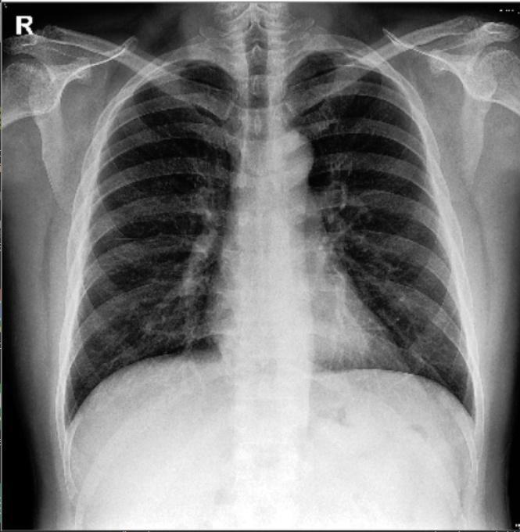 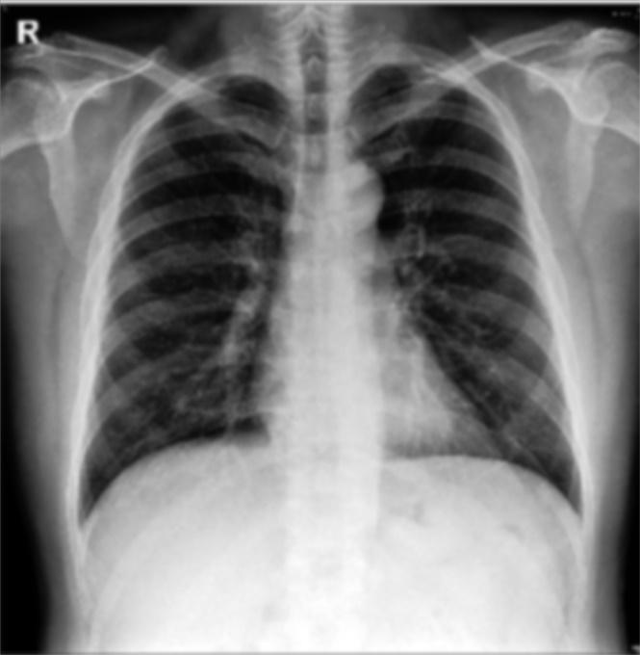

*Figure 5. The images before (left) and after processing of the Laplacian filter (center) and Gaussian Blur filter (right).*

**3.4. Harris corner detector to compare the two filters**

By using the Harris corner detection method, we investigated which filter allows for better corner detection. ‘R’ is an alphabet which means the right side in the chest x-ray and is an independent image artificially inserted into the image to indicate the direction. It is the most clearly distinguished image in the chest x-ray image, and we have identified it as a target to see if the algorithm distinguishes ‘R’. As a result, the ‘R’ on the top left corner of Gaussian blurred image could not be detected, whereas the ‘R’ of the Laplacian filtered image could be detected. This shows that the Laplacian filter produces a better image quality (Fig. 6) than Gaussian blur filtered image. Briefly, Harris Corner detection has preserved "R" in the image converted to Laplacian filter, but the converted image to Gaussian blur filter resulted in an error in which "R" was expressed as noise. This result shows that the method of changing Laplacian filter has higher clarity.

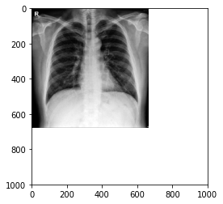 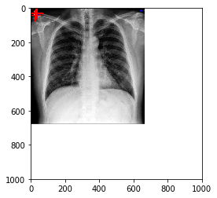

*Figure 6. The images after processing the Gaussian blur filter (left) and Laplacian filter (Right). After performing the Harris corner detector algorithm, the “R” not found in the left image is recognized as corner points (red cross) in the right image.*

**3.5. High-dynamic-range imaging (HDR)**

Equalization and Laplacian filtering, as shown above, enhanced the images of ribs that were hard to see in the original Chest X-ray. Using these two post-process image, we implemented a HDR image using one of the deep learning method - generative adversarial network (GAN). And final images were converted to 8-bit image putting this image on a smart phone or computer monitor which can express the HDR image, we were able to easily identify the bone from the modified Chest x-ray. Figure 7 shows the final product of rib prominent chest X-ray after putting this image on a computer monitor which can express the HDR image. We were able to easily identify the ribs from the modified Chest x-ray.

 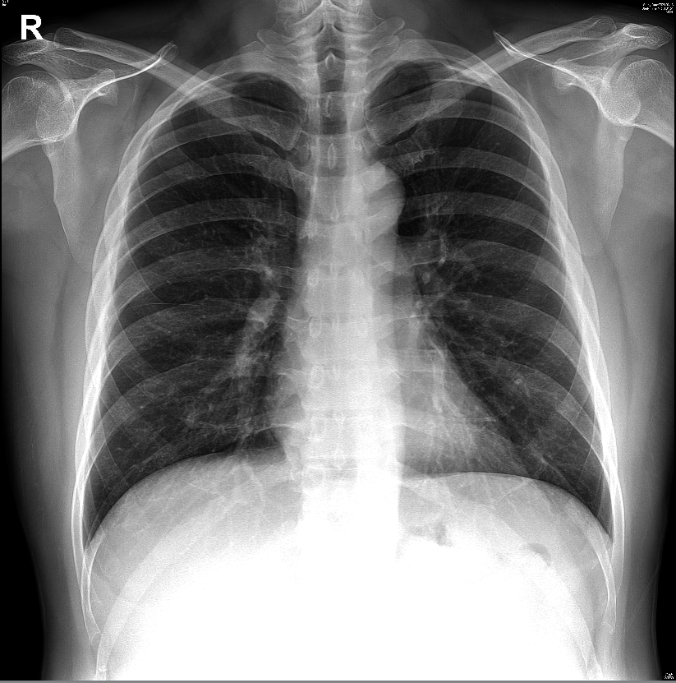

*Figure 7. The HDR images (right) after processing GAN. In the final HDR image (right), the lung shadow is reduced, making the rib shadow stand out when compared with the original image (left).*

**Discussion**

To this day, single projection X-ray images remain an important diagnostic tool. A well-known limitation is that single projections are unable to resolve overlapping structures, making it difficult to assess or visualize certain three-dimensional features. However, it can be expected that this limitation can be overcome by using appropriate image processing filters that reduce noise and enhance the visibility of various features.

In this paper, we have discussed a variety of methods including histogram equalization, Laplacian filter, Gaussian blur, and HDR. In the case of histogram equalization, the range for color intensity had been widened, as a result creating higher contrast. Histogram equalization is an image enhancement method that calculates pixel values of an output image by using the cumulative distribution as a transformation function. Histogram equalization transforms a low-contrast input image with a narrow range of pixel values into a high-contrast output image with a wider range of pixel values. In other words, if the distribution of pixel values in the original image is narrow and concentrated around a certain value, either dark or bright, histogram equalization produces a clearer image with a wider distribution of pixel values.

The Laplacian filter was effective in enhancing the sharp discontinuities.10 The Gaussian blur resulted in considerable noise reduction but the overall image quality had been degraded and the edges became more opaque. This difference was proved by Harris corner detection method. A corner is a point whose local neighborhood stands in two dominant and different edge directions. Edge points are the point of rapid change in one direction and the points without change are called flat points. This method was used under the assumption that the distinction between images could be difficult if the noise was severe. As a result, it was confirmed that the difference between the two images was meaningfully distinguished.

The region of interest (the areas of potential abnormalities to be diagnosed) can be selected and magnified for further examination of the equalized image. Because it is difficult to distinguish a specific area from the whole X-ray image, a more detailed diagnosis can be performed by segmenting out only a specific range. As a result, the resolution quality enhances significantly

Regarding the High-Dynamic-Range (HDR) method, switching to high resolution HDR can definitely give good results for image interpretation. However, to view HDR images, one needs a compatible device. As a typical display cannot rasterize an HDR image, the latter must be converted back to an 8-bit SDR image, which is also known as tone-mapping.

Digital images are generally composed of 3 channels of red, green and blue (RGB), which are encoded using 8 bits per channel. Therefore, the brightness of a color channel can be represented by an integer number in the range from 0 to 255. These digital images are called standard dynamic range (SDR) images. However, the dynamic range of brightness itself is highly narrow, dark areas or bright areas both could possibly not be properly expressed. As a result, there is a big difference between the scenes we see with our naked eye and the digital images that contain them. In order to overcome such limitations, this paper would present a method which reproduces a greater dynamic range of luminosity.11

HDR images are usually created by combining images taken with varying degrees of exposure. Unlike SDR images, which are expressed at 8 bits per channel, HDR images are expressed at 16 or 32 bits per channel, allowing for a much wider range of colors and brightness, and more realistic representation of the scene. To view HDR images, one needs a device capable of displaying HDR images. However, as a typical display device cannot represent an HDR image, it must be converted back to an 8-bit SDR image. The technique used at this time is tone-mapping. This image is called a tone-mapped HDR image.

In addition, the reader also takes an important role in displaying the high resolution HDR method. The X-ray can be deciphered only when the reader has the corresponding capacity to express such high resolution images. While conducting this research, when analyzed on a high-resolution computer, the image quality was not impaired, but on a computer screen with a lower resolution, the resolution was conspicuously degraded. In other words, although brightness control and filtering methods are important factors in deciphering images of X-rays, before that, a high-definition reader that is capable of reading high-definition X-rays are equally, or even more important.

In summary, we were able to obtain some satisfactory enhancement of bone images in a chest x-ray by using various methods for image post-processing, However, in this study, we only succeeded in extracting bone structures in one specific image. The future studies should address a wider and more statistically significant set of images including bones and soft tissues. Although open source programs (OpenCV) that are publicly available were used in this study, it is expected that the research on advanced image processing techniques will be developed in the future by developing artificial intelligence or improved image acquisition processes.

**References**

1. <https://emedicine.medscape.com/article/825981-overview>)

2. http://[www.OpenCV.org](http://www.opencv.org/)

3. <https://docs.opencv.org/3.4/d4/d1b/tutorial_histogram_equalization.html>

4. https://docs.opencv.org/3.4/da/d7f/tutorial_back_projection.html

5. <https://www.harrisgeospatial.com/docs/LaplacianFilters.html>

6. https://docs.opencv.org/master/d4/d13/tutorial_py_filtering.html

7. <https://medium.com/data-breach/introduction-to-harris-corner-detector-32a88850b3f6>

8. <https://docs.opencv.org/master/dc/d0d/tutorial_py_features_harris.html>

9. <https://docs.opencv.org/3.4/d2/df0/tutorial_py_hdr.html>

10. <https://www.sciencedirect.com/topics/engineering/laplacian-filter>

11. <https://bskyvision.com/703>